Bernardo, Noah Halili

Dela Cruz, Richter

Escober, Matt

Fernandez, Matthew

Padua, Alexandra

Documentation for the CSARCH2 Exhibit

### Before the booth was set up.

Richter and Alexandra find some decorations for the booth. They bought the other materials in Dangwa, Dapitan Arcade, and Glorietta

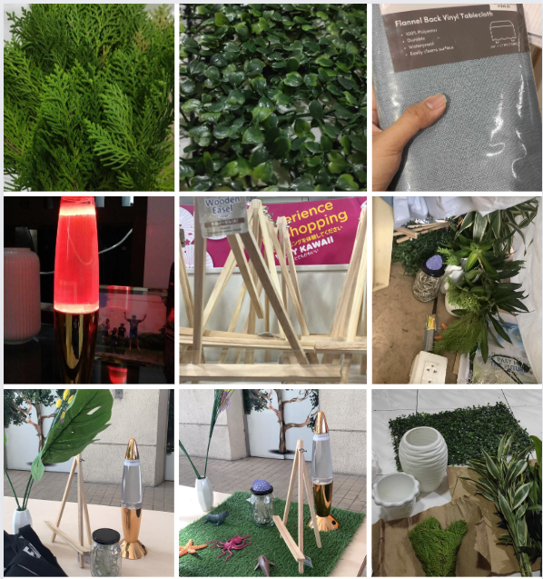

What the booth looked like before it was set up for the 2nd day

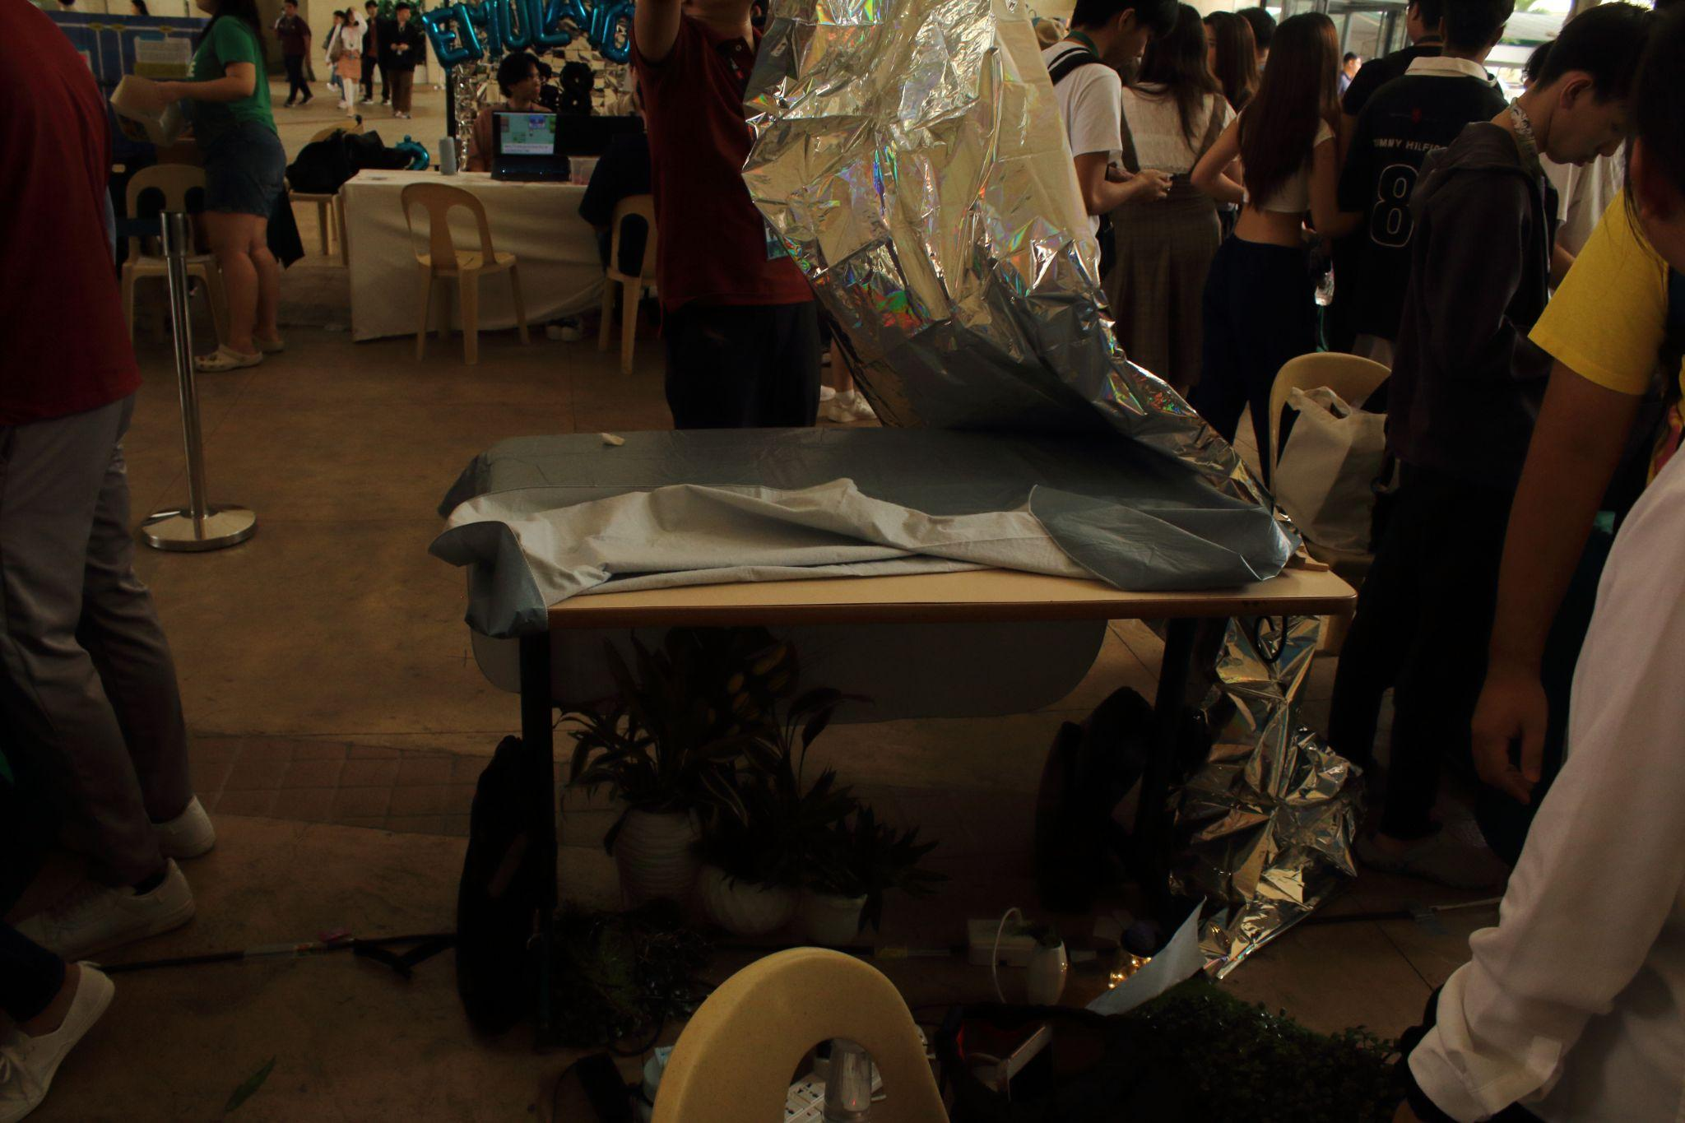

What the booth looked like before it was set up on the 1st day

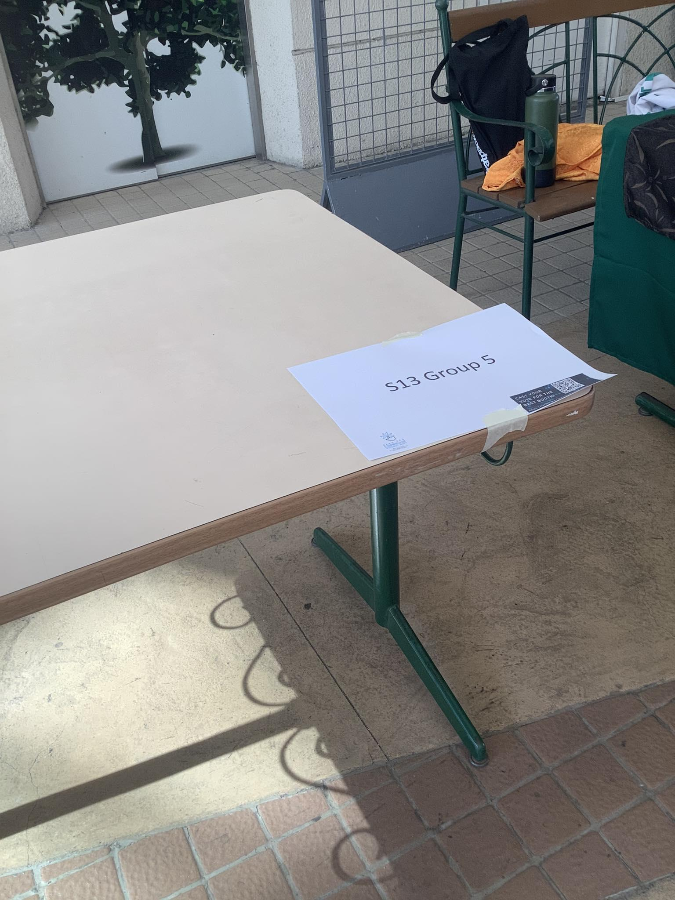

### After the booth was set up.

(Thursday) Richter set up the booth by 6:40am

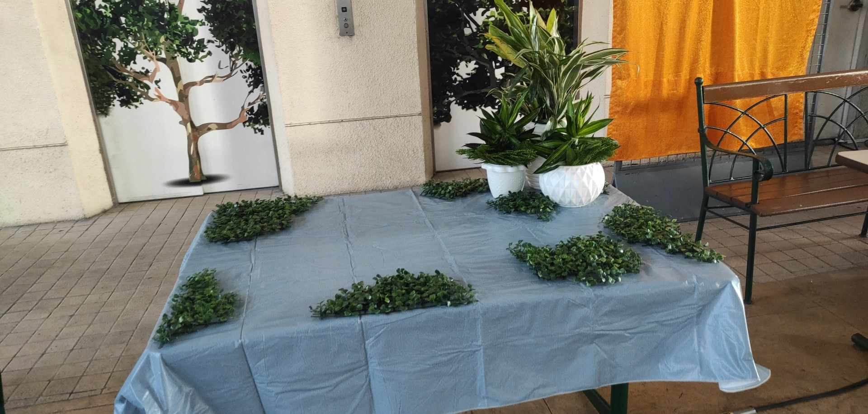

(Thursday) Alexandra set up her components before 9:00am

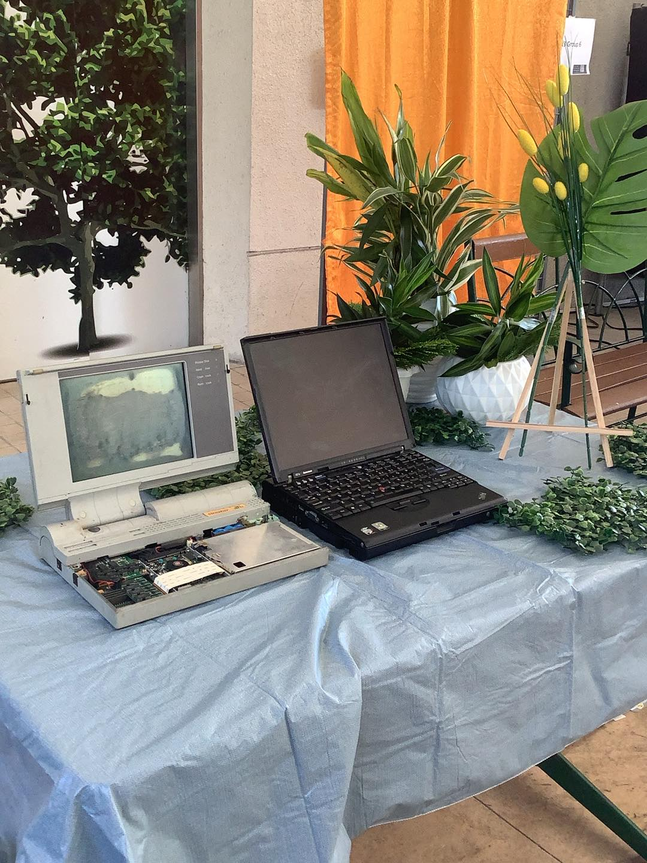

(Friday) Richter set up the booth by 6:30am and Alexandra added some decorations by 7:30am

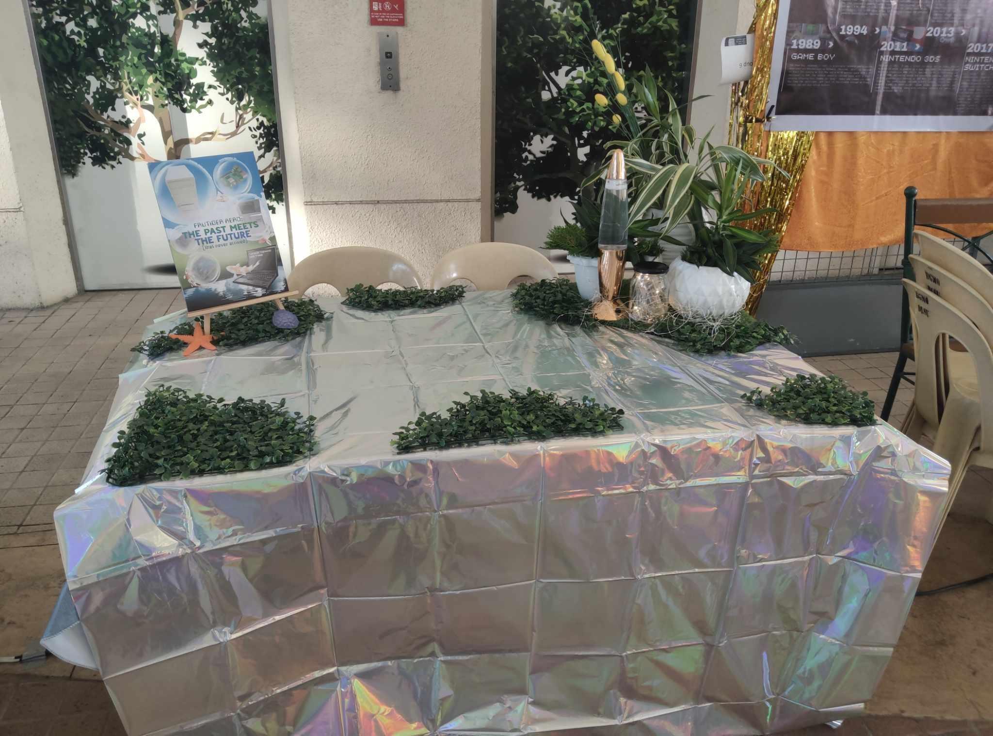

Matthew Escober, Matthew Fernandez, and Alexandra Padua added their components before 9:00am  
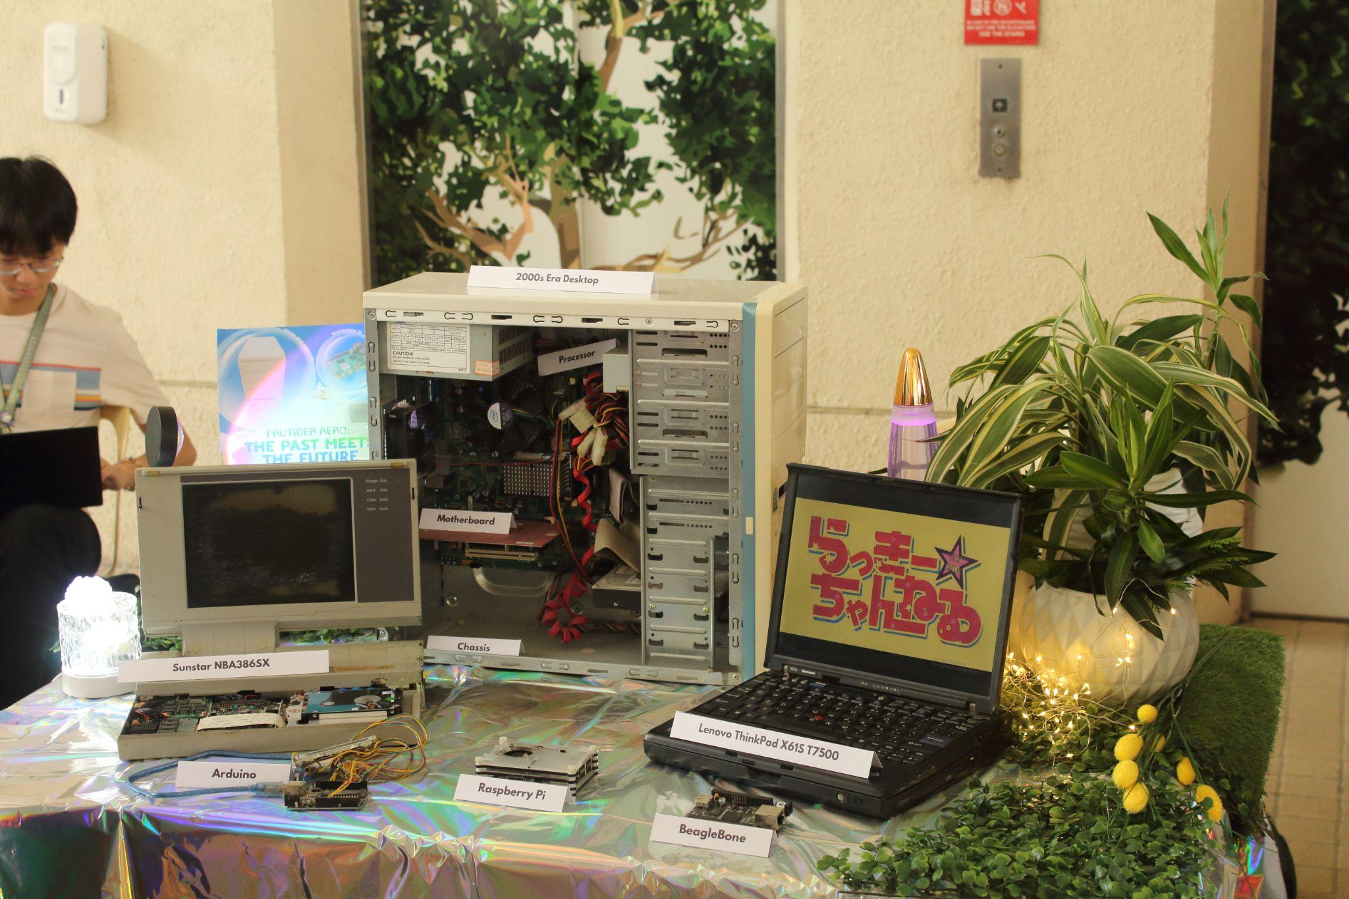

Noah showcasing the final set up

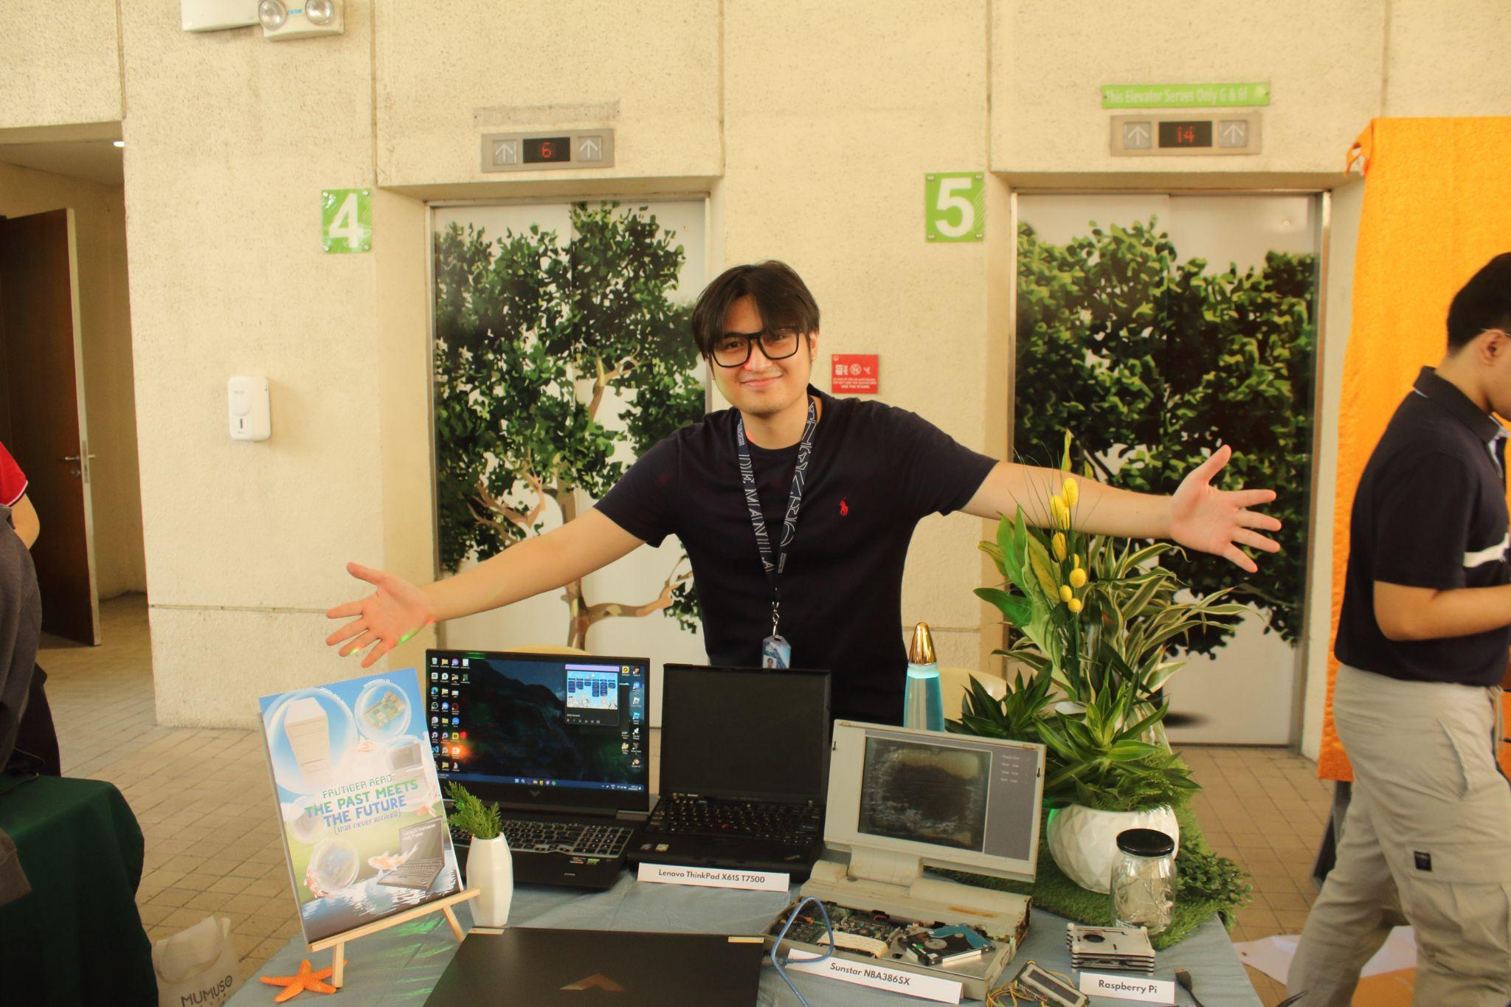

Close-up of the finished set up

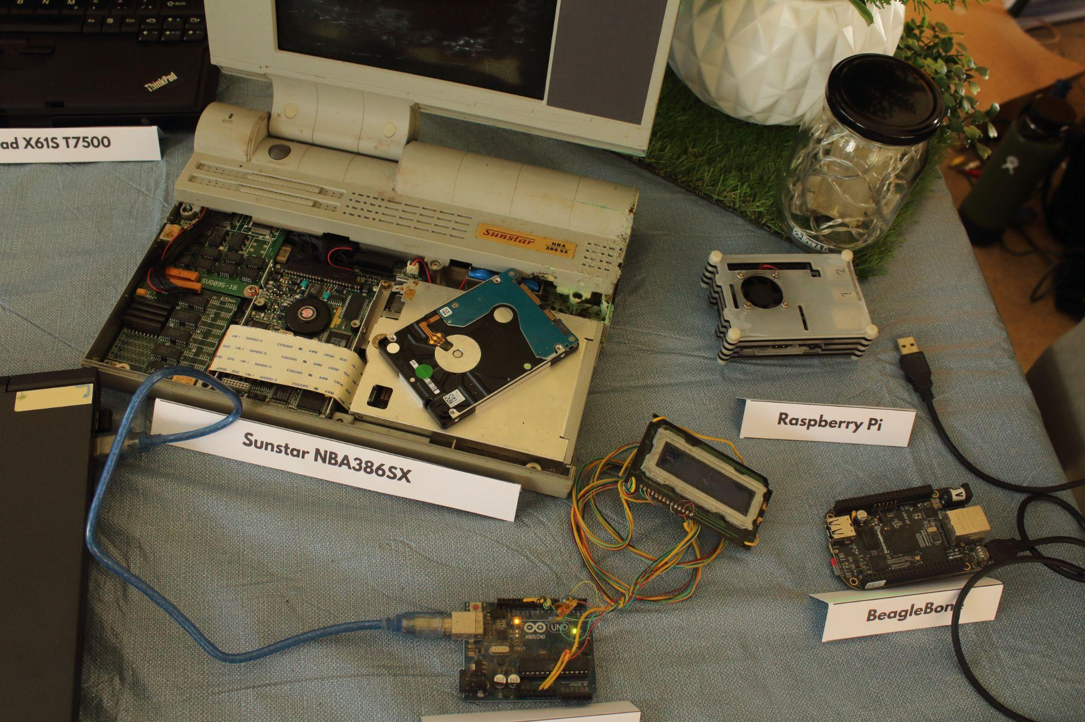

### Members manning the booth (for both days, with timestamp).

Richter, Alexandra, and Matt manning the booth on the 1st day (Picture taken at 10:41AM)

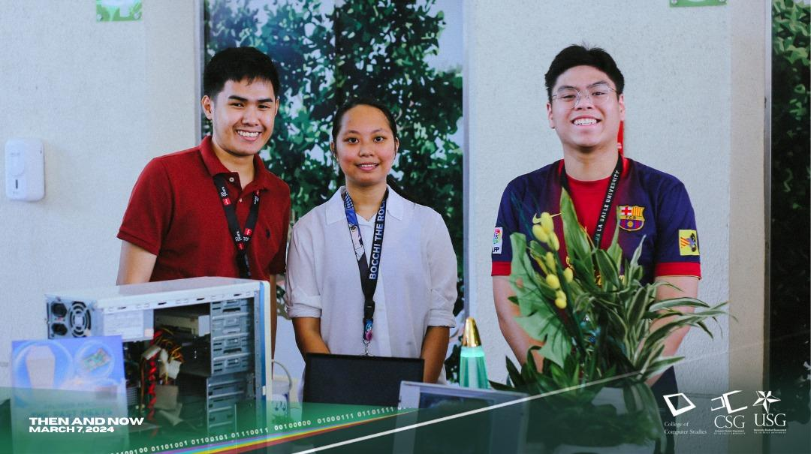

Noah, Matthew, and Alexandra manning the booth on the 1st day (Picture taken at 2:44PM)

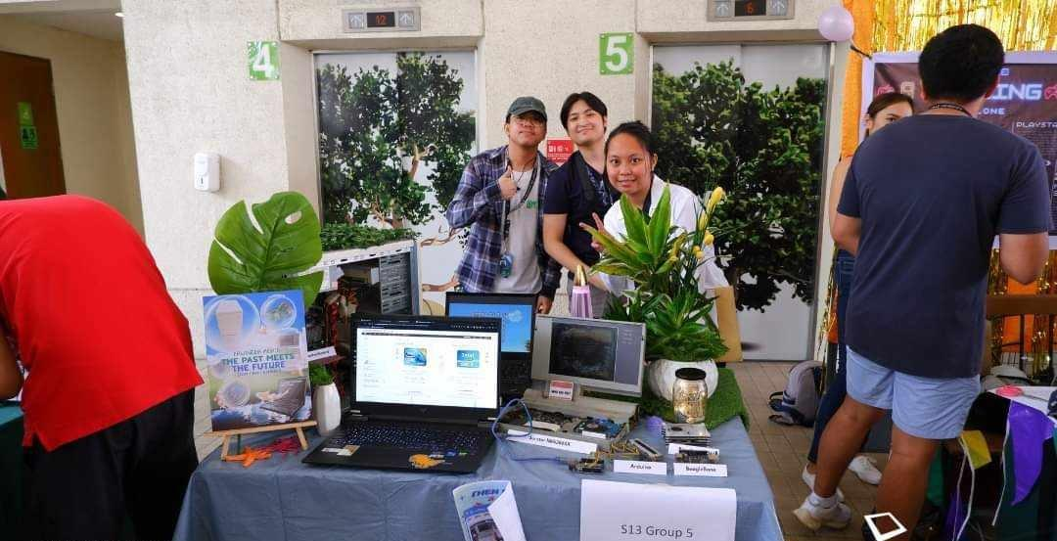

Noah manning the booth on the 2nd day (Picture taken at 1:08PM)

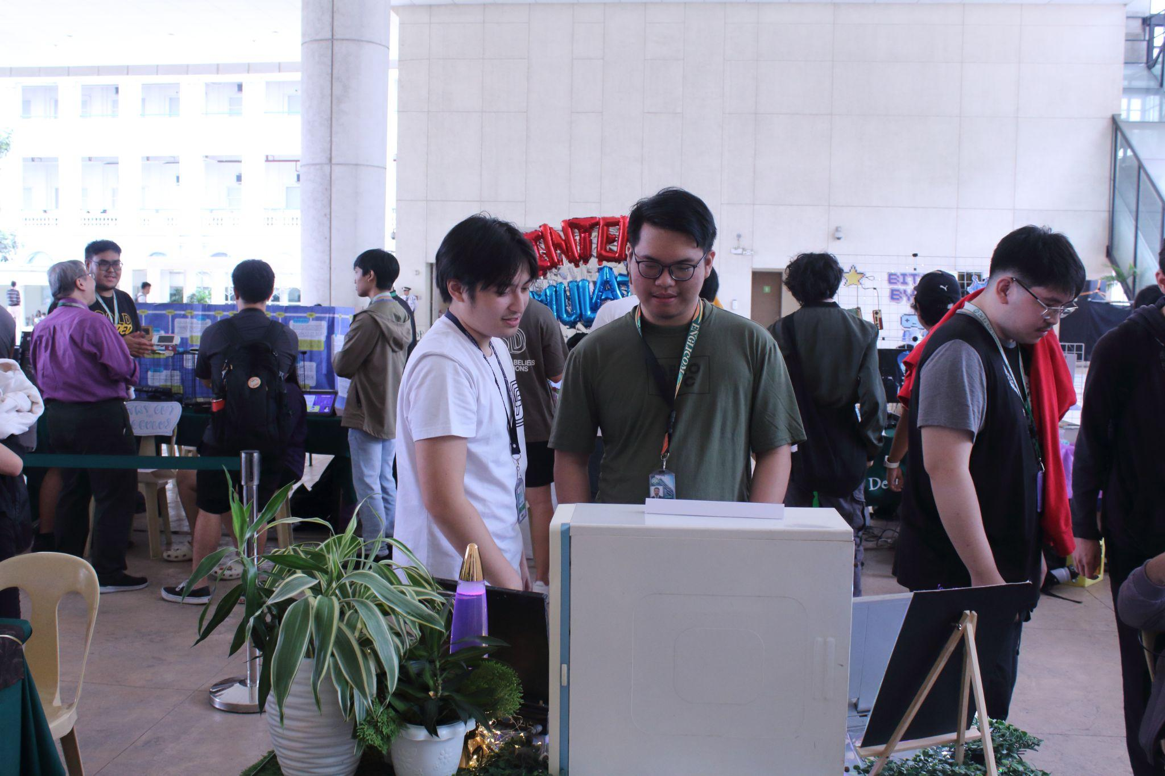

Matthew manning the booth on the 1st day (Picture taken at 1:17PM)

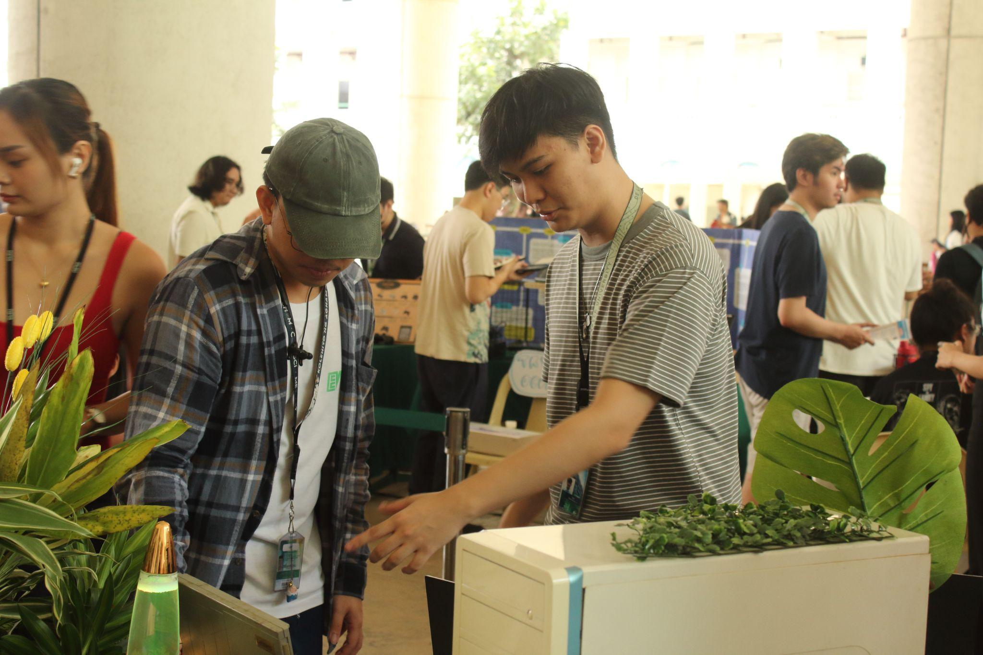

Noah manning the booth on the 1st day (Picture taken at 12:57PM)

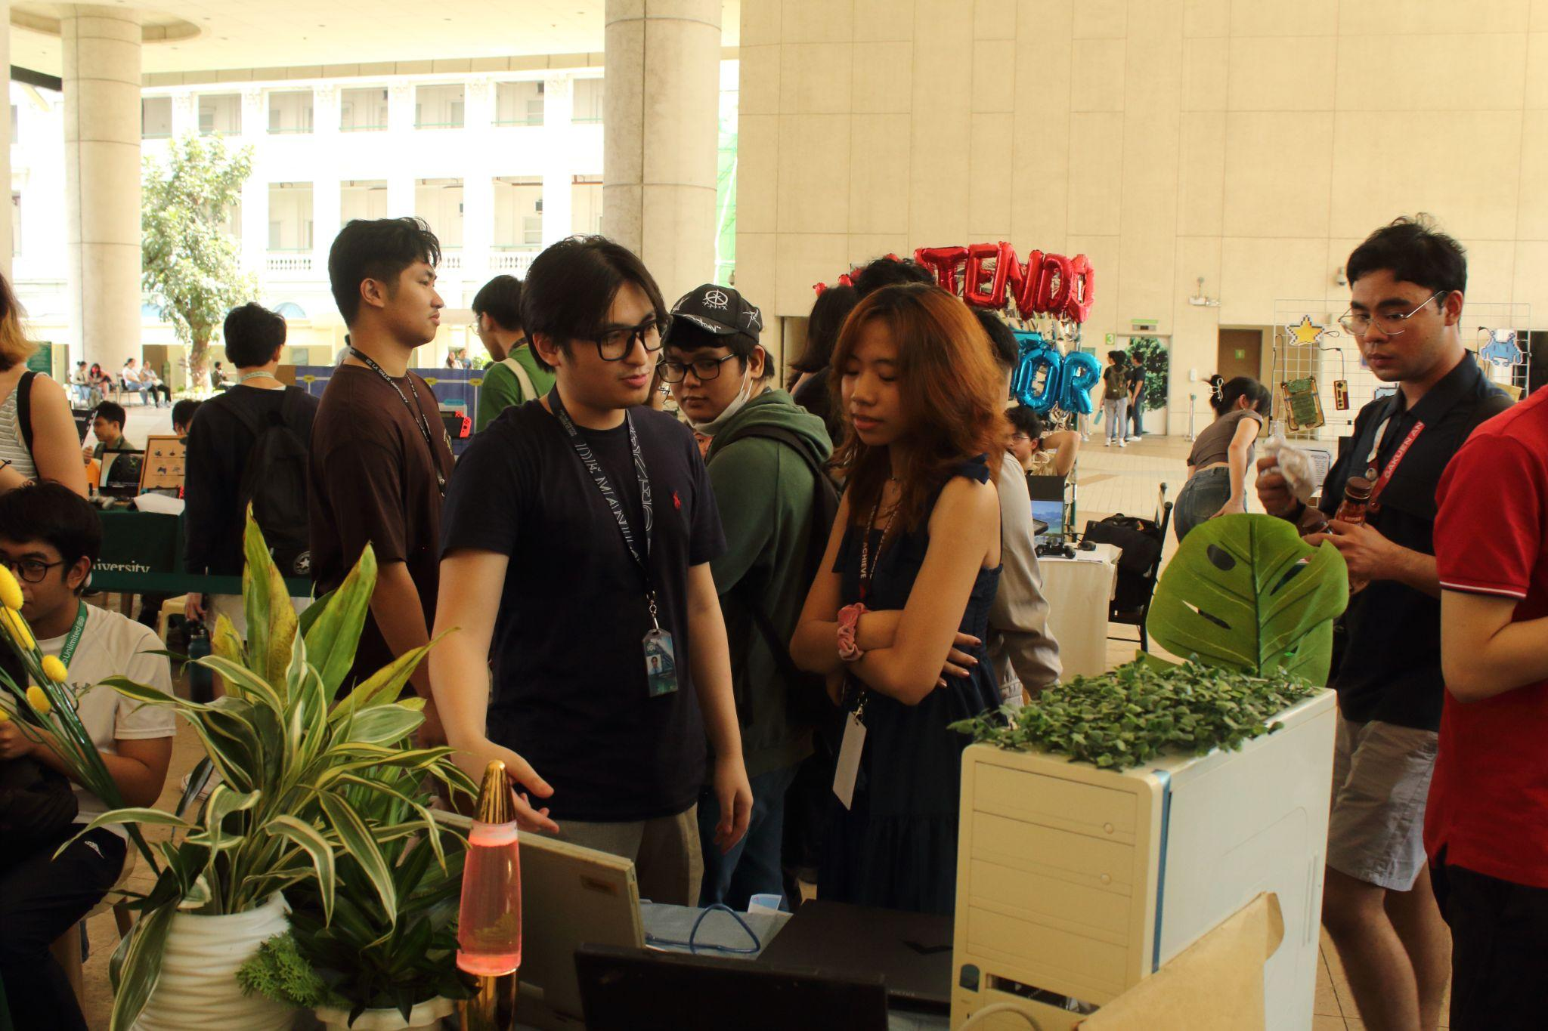

Alexandra manning the booth on the 1st day (Picture taken at 2:56PM)

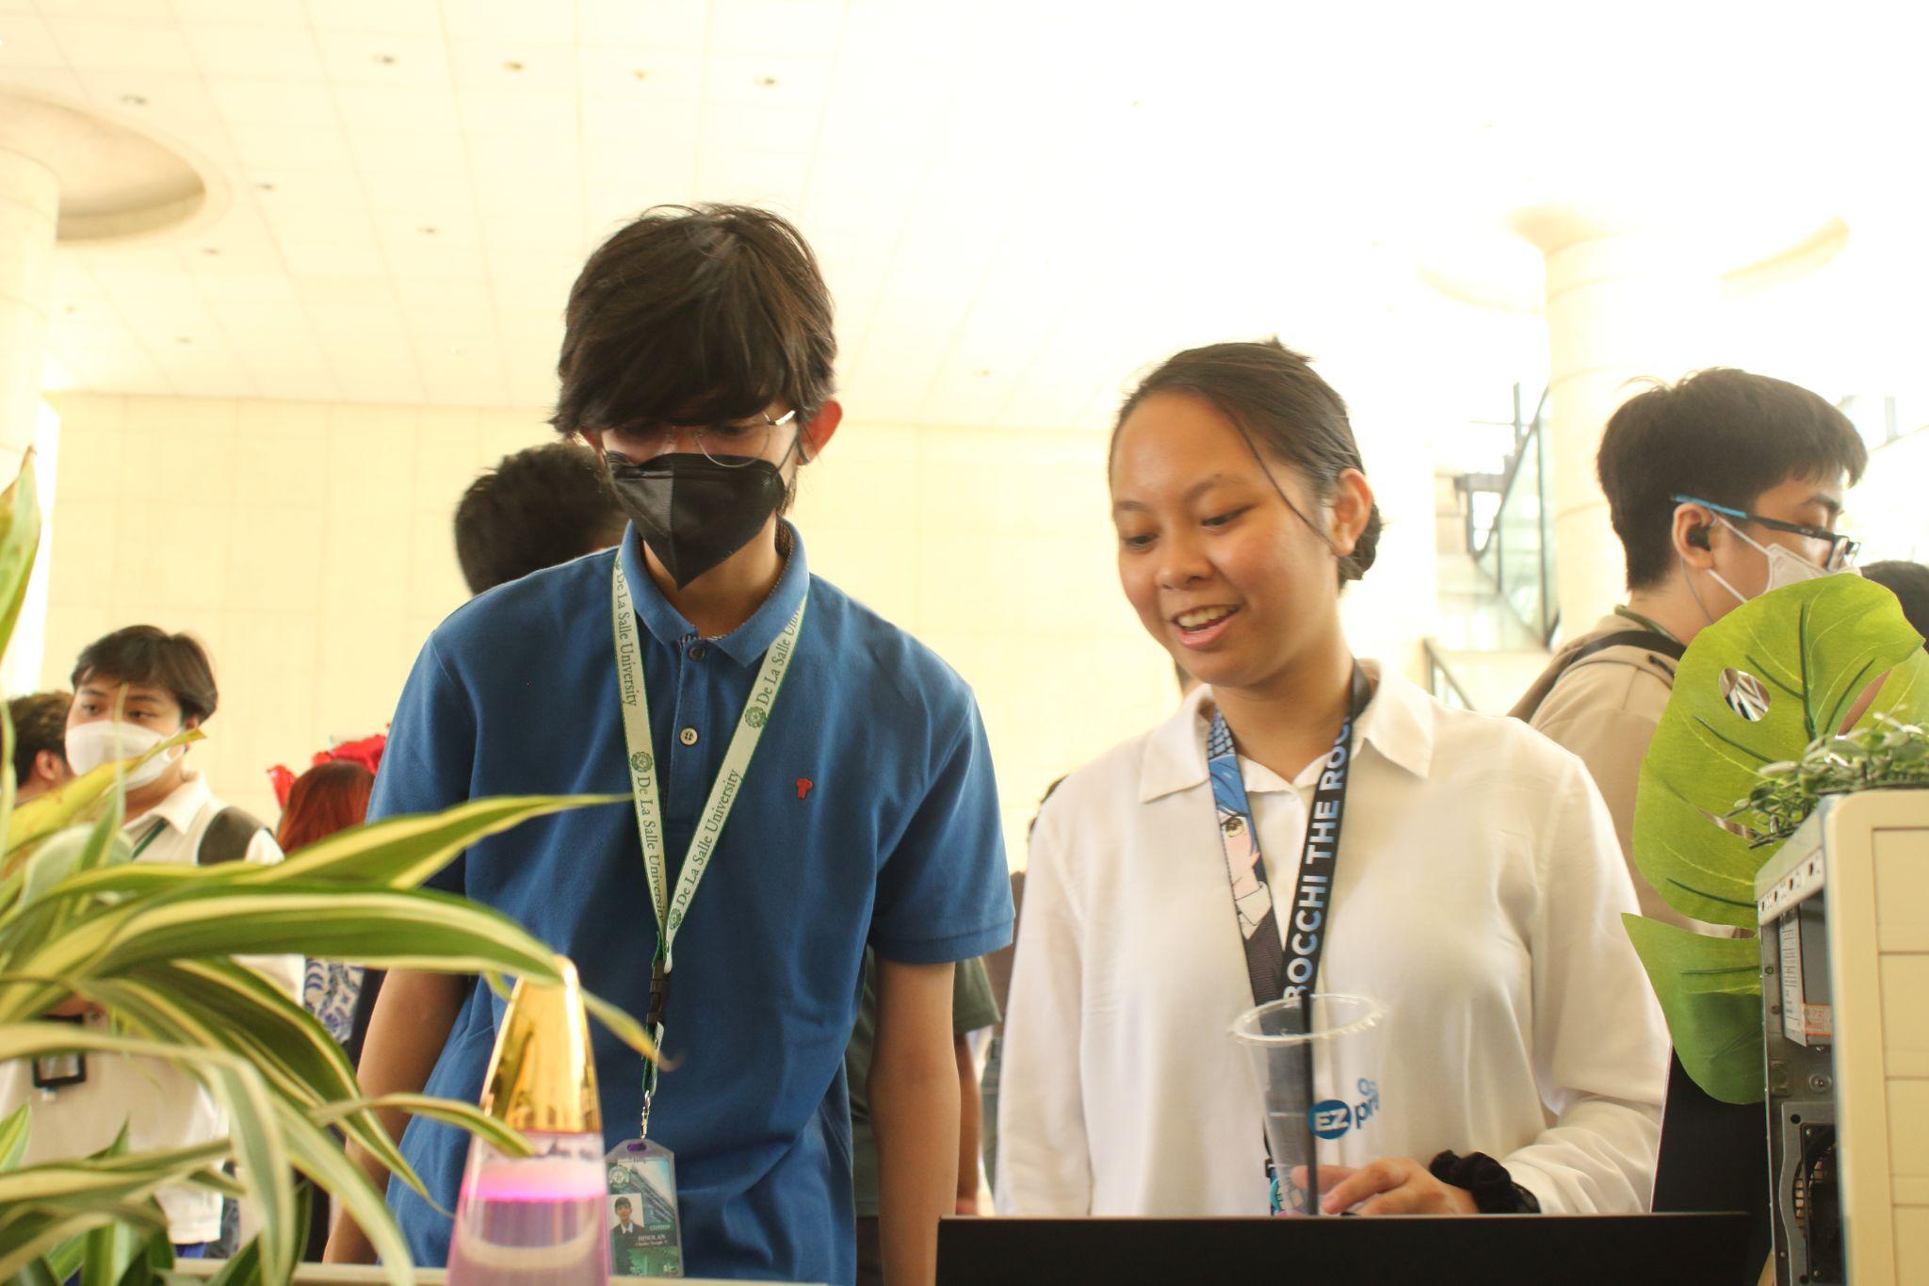

Matthew and Alexandra manning the booth on the 1st day (Picture taken at 11:08AM)

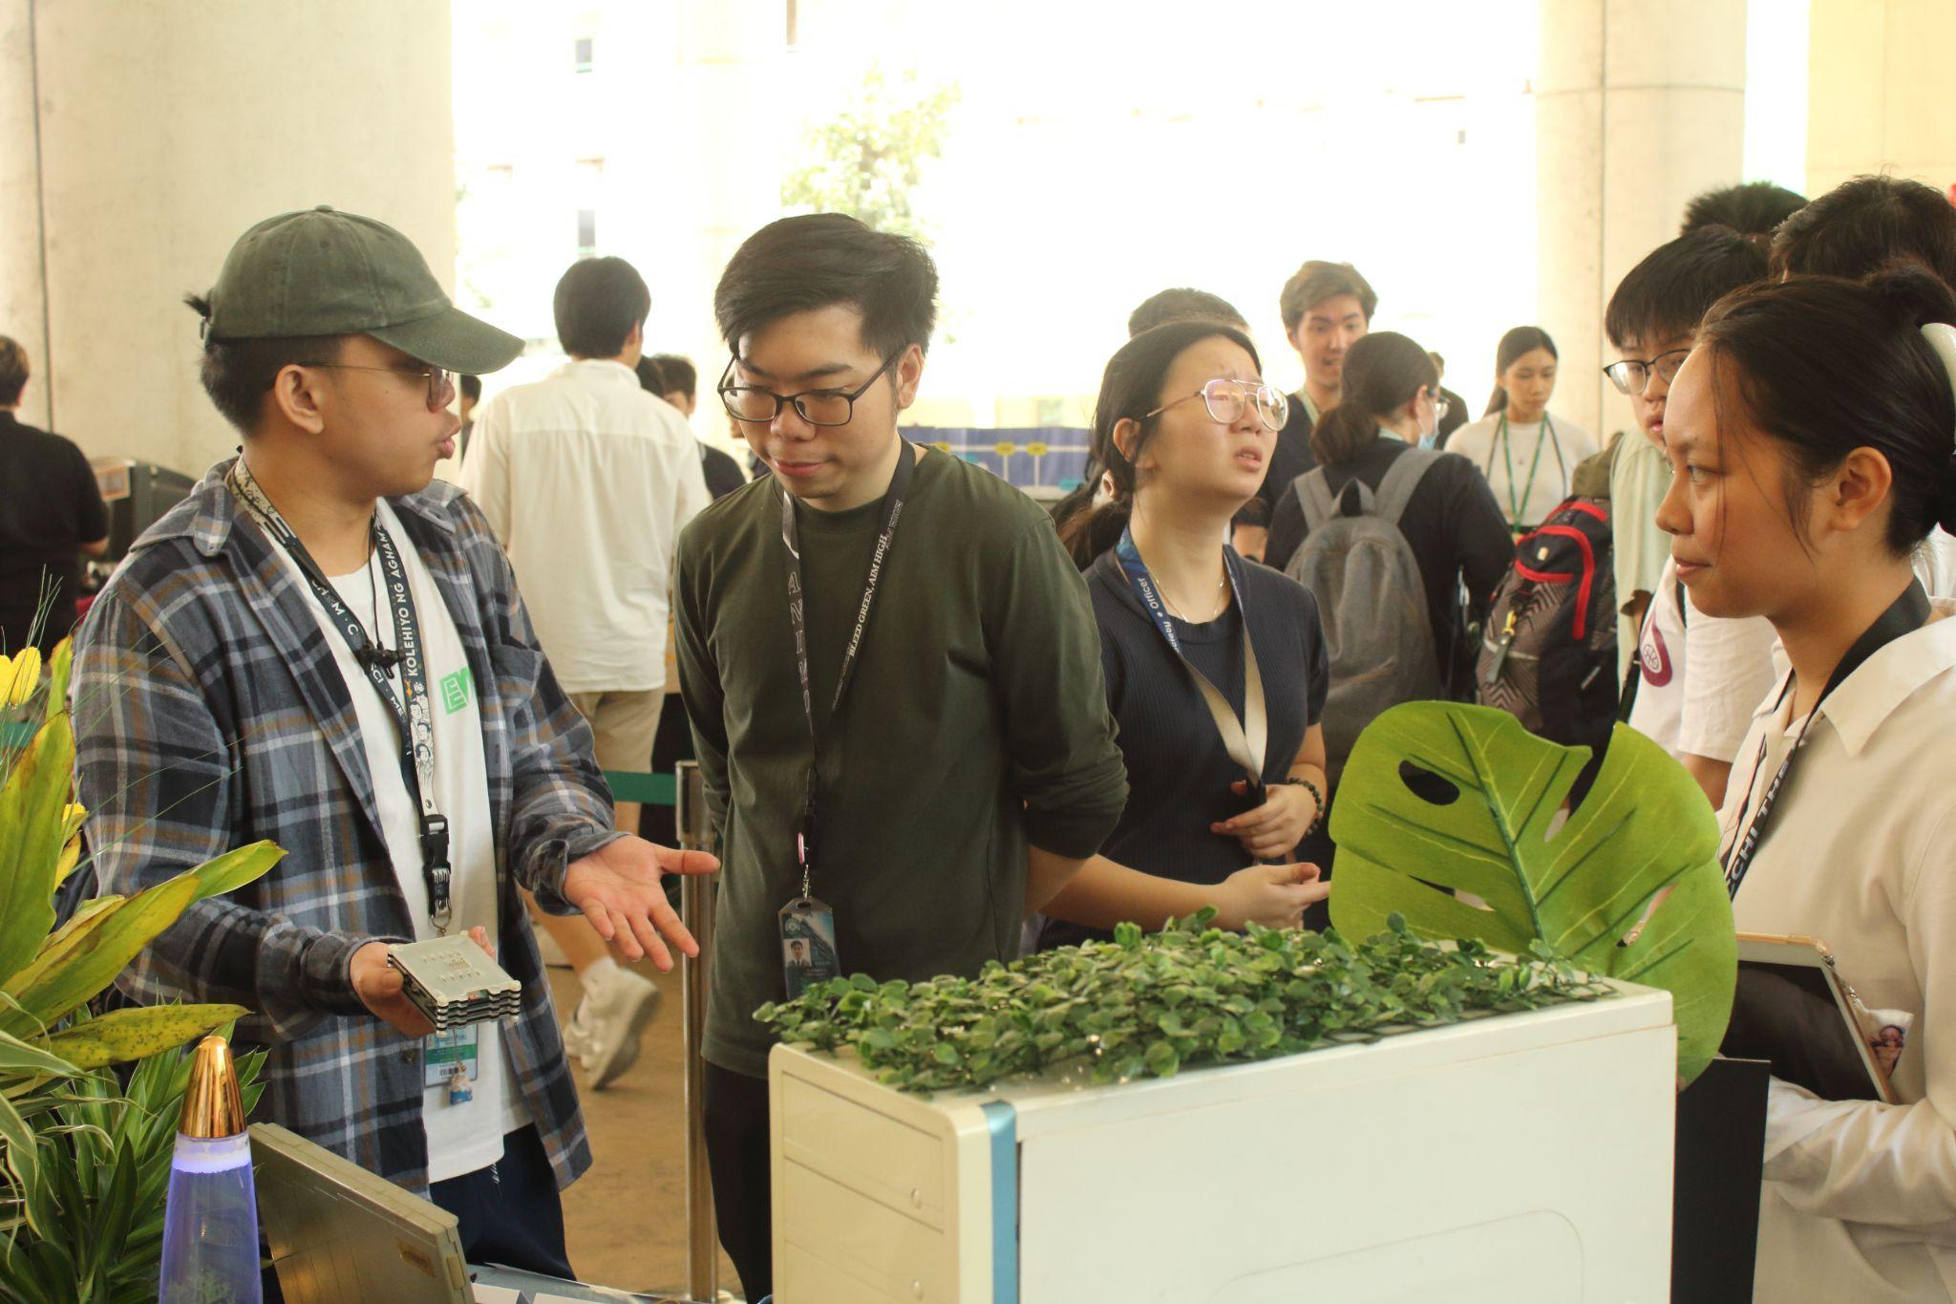

### Guests who visited and inquired about your exhibit.

Professors inquiring about the booth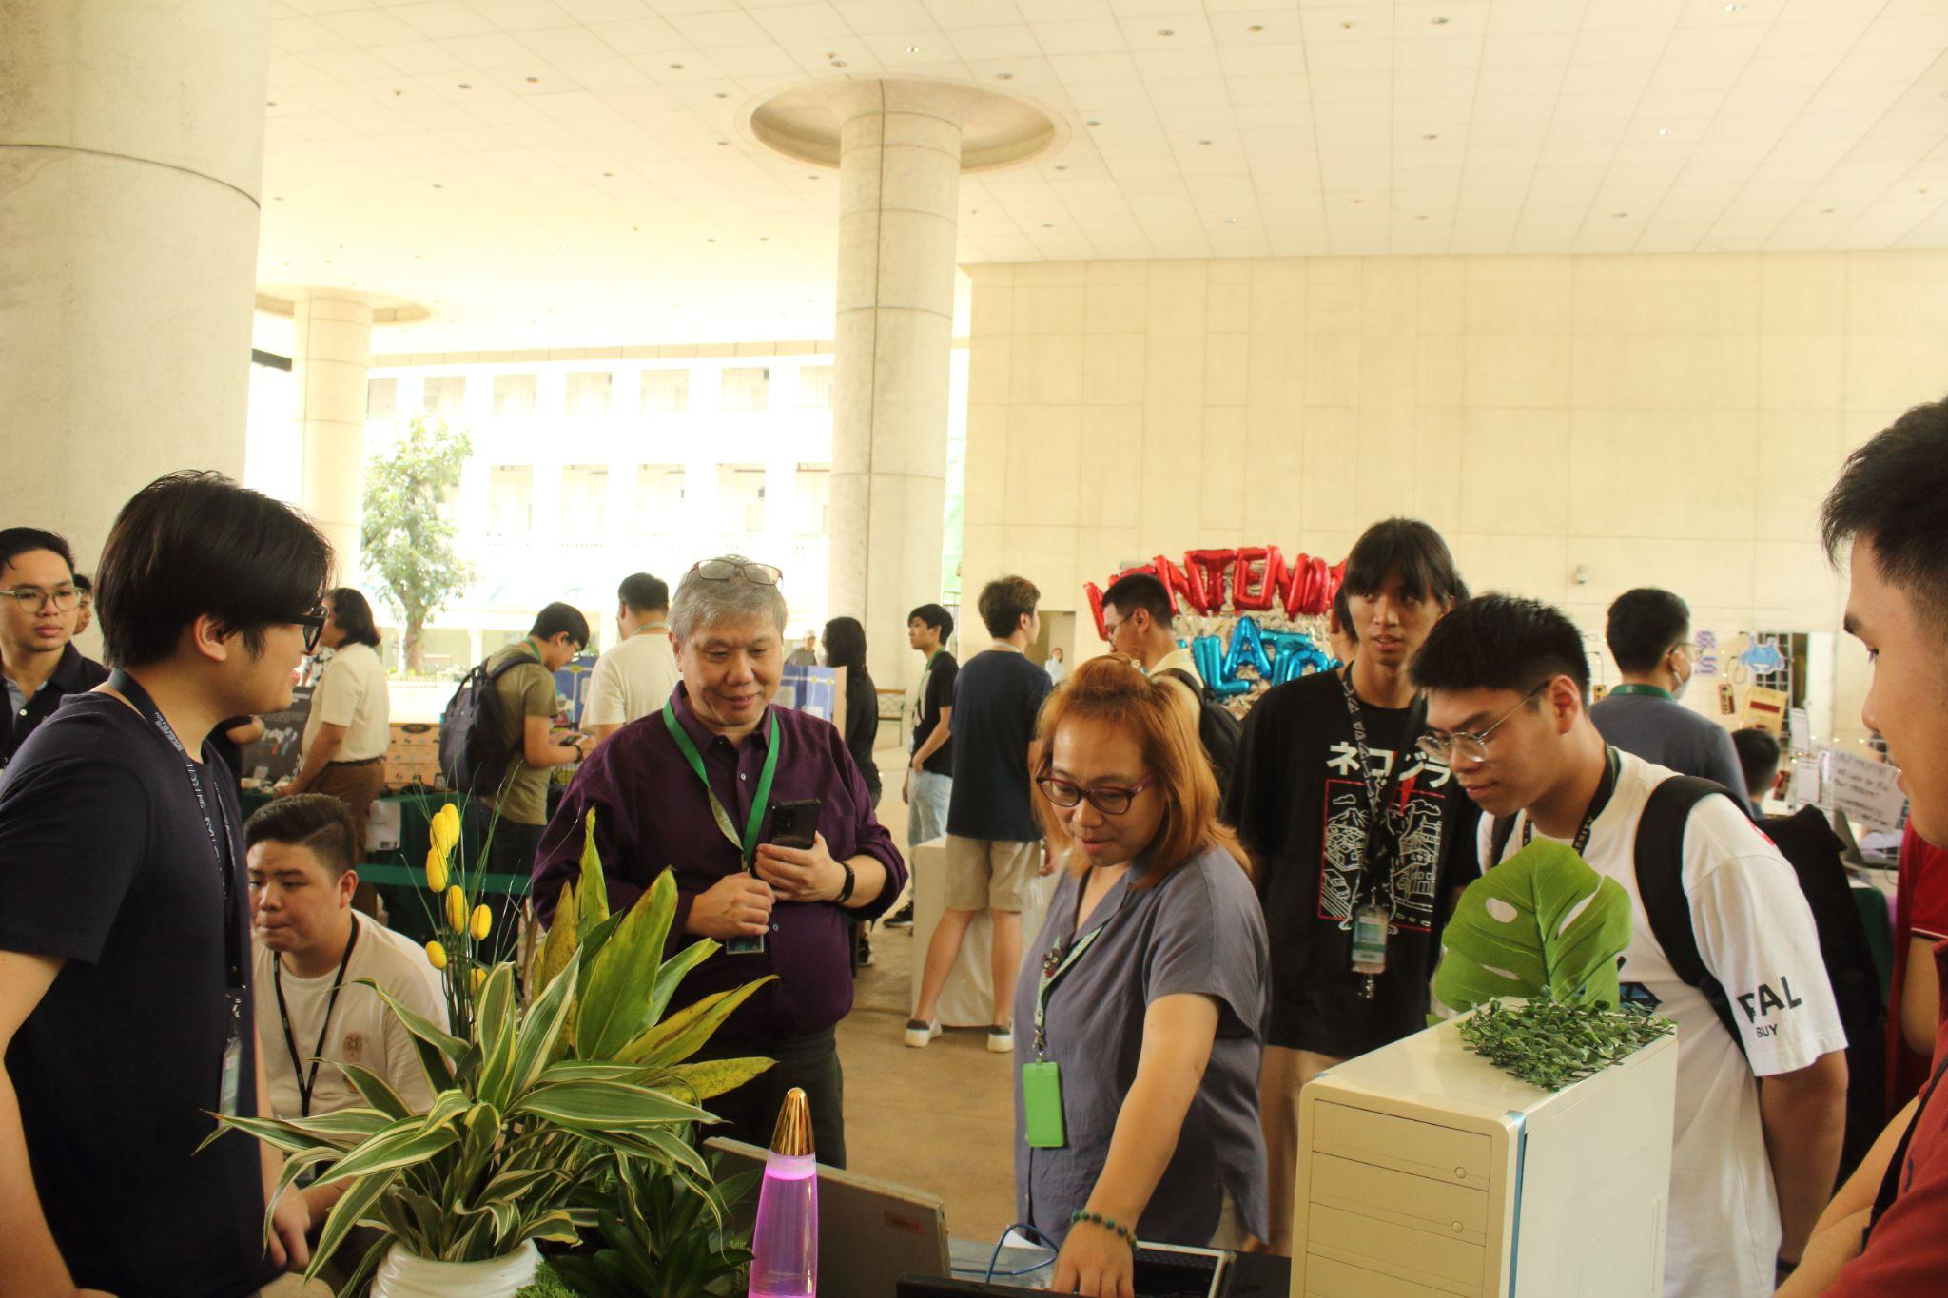Matthew showcasing the exhibit to other students

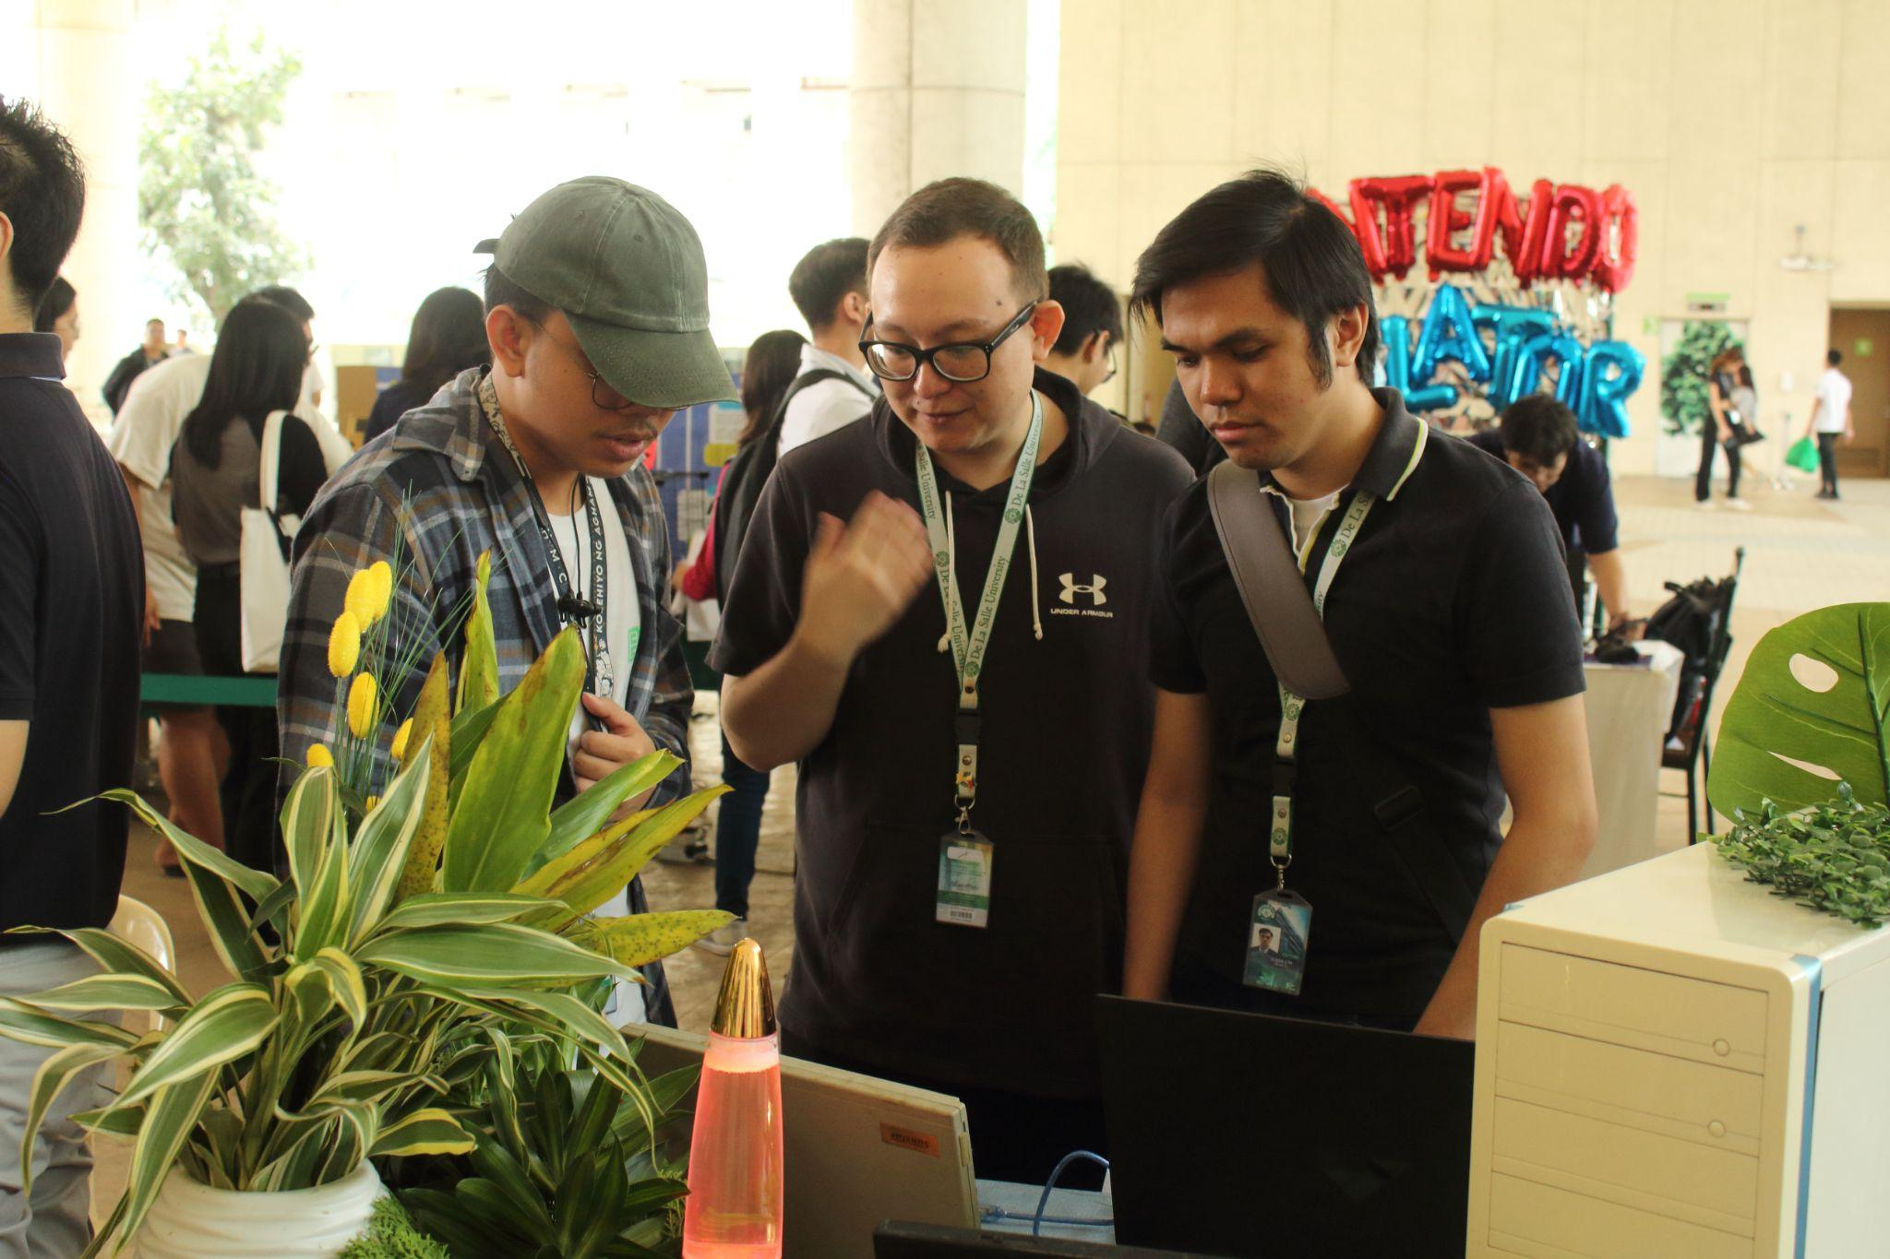

Noah showcasing the exhibit to other students

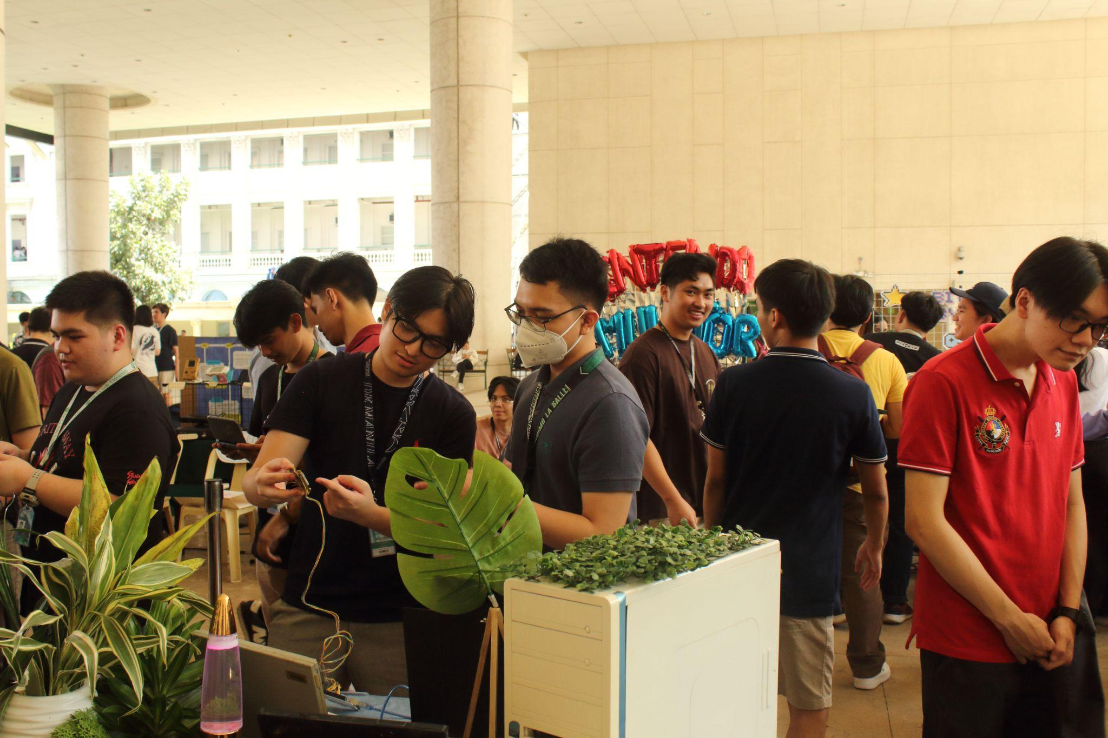

Fellow student trying out the Arduino demo

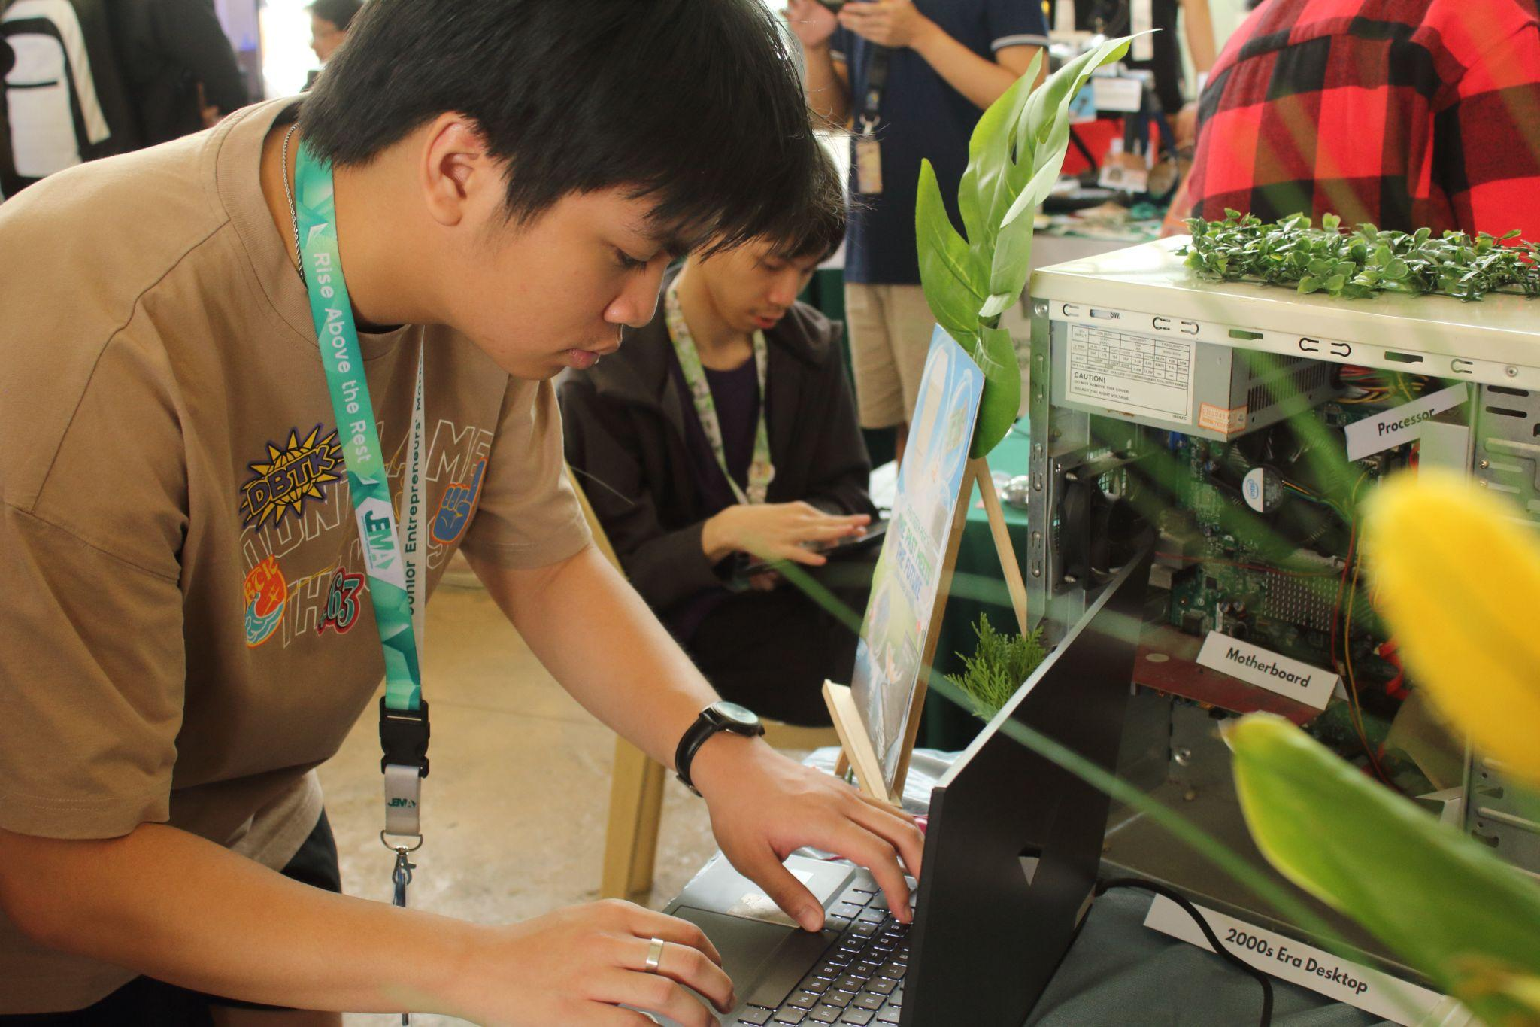

Students examining first hand embedded systems

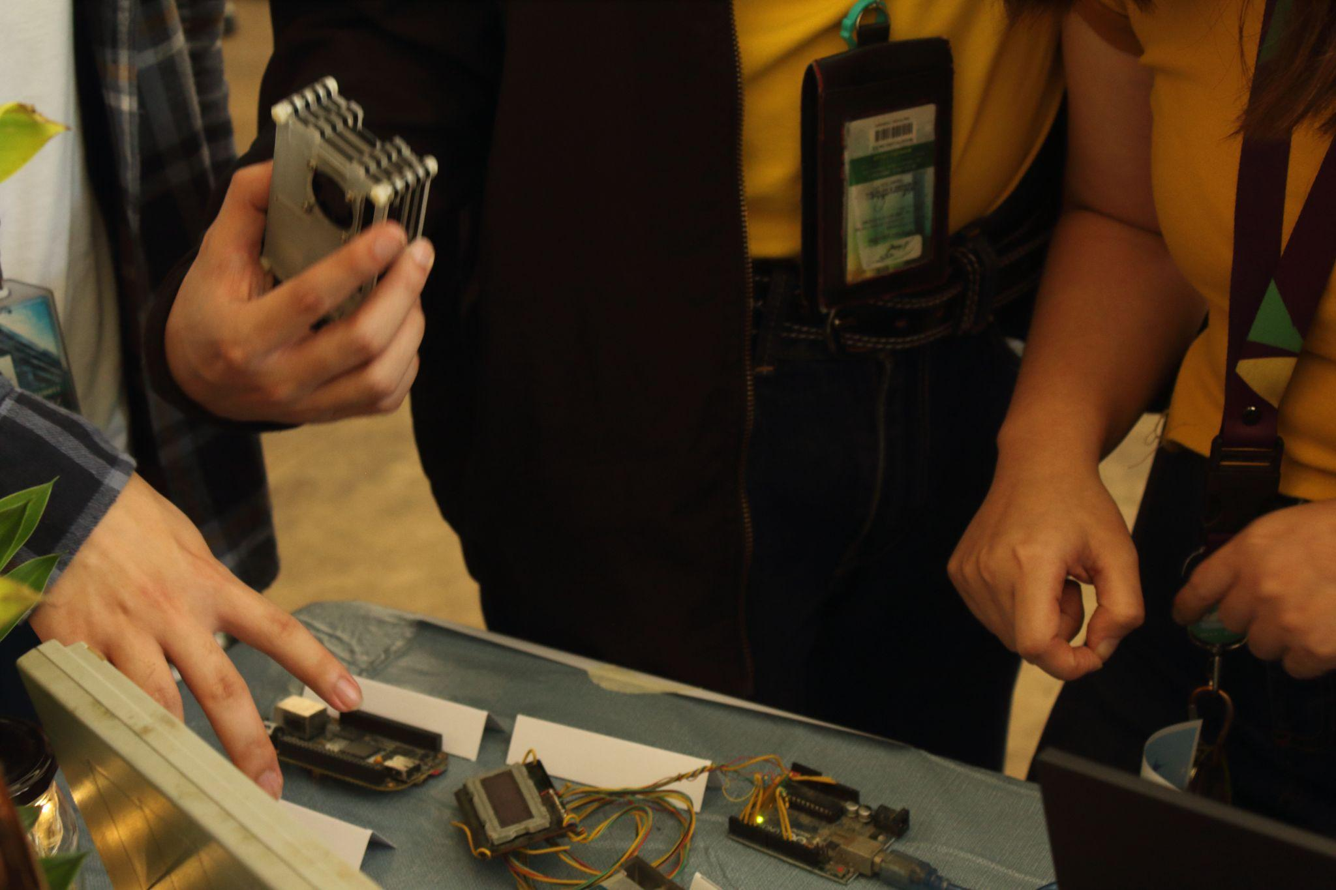

Students observing and photographing the exhibit

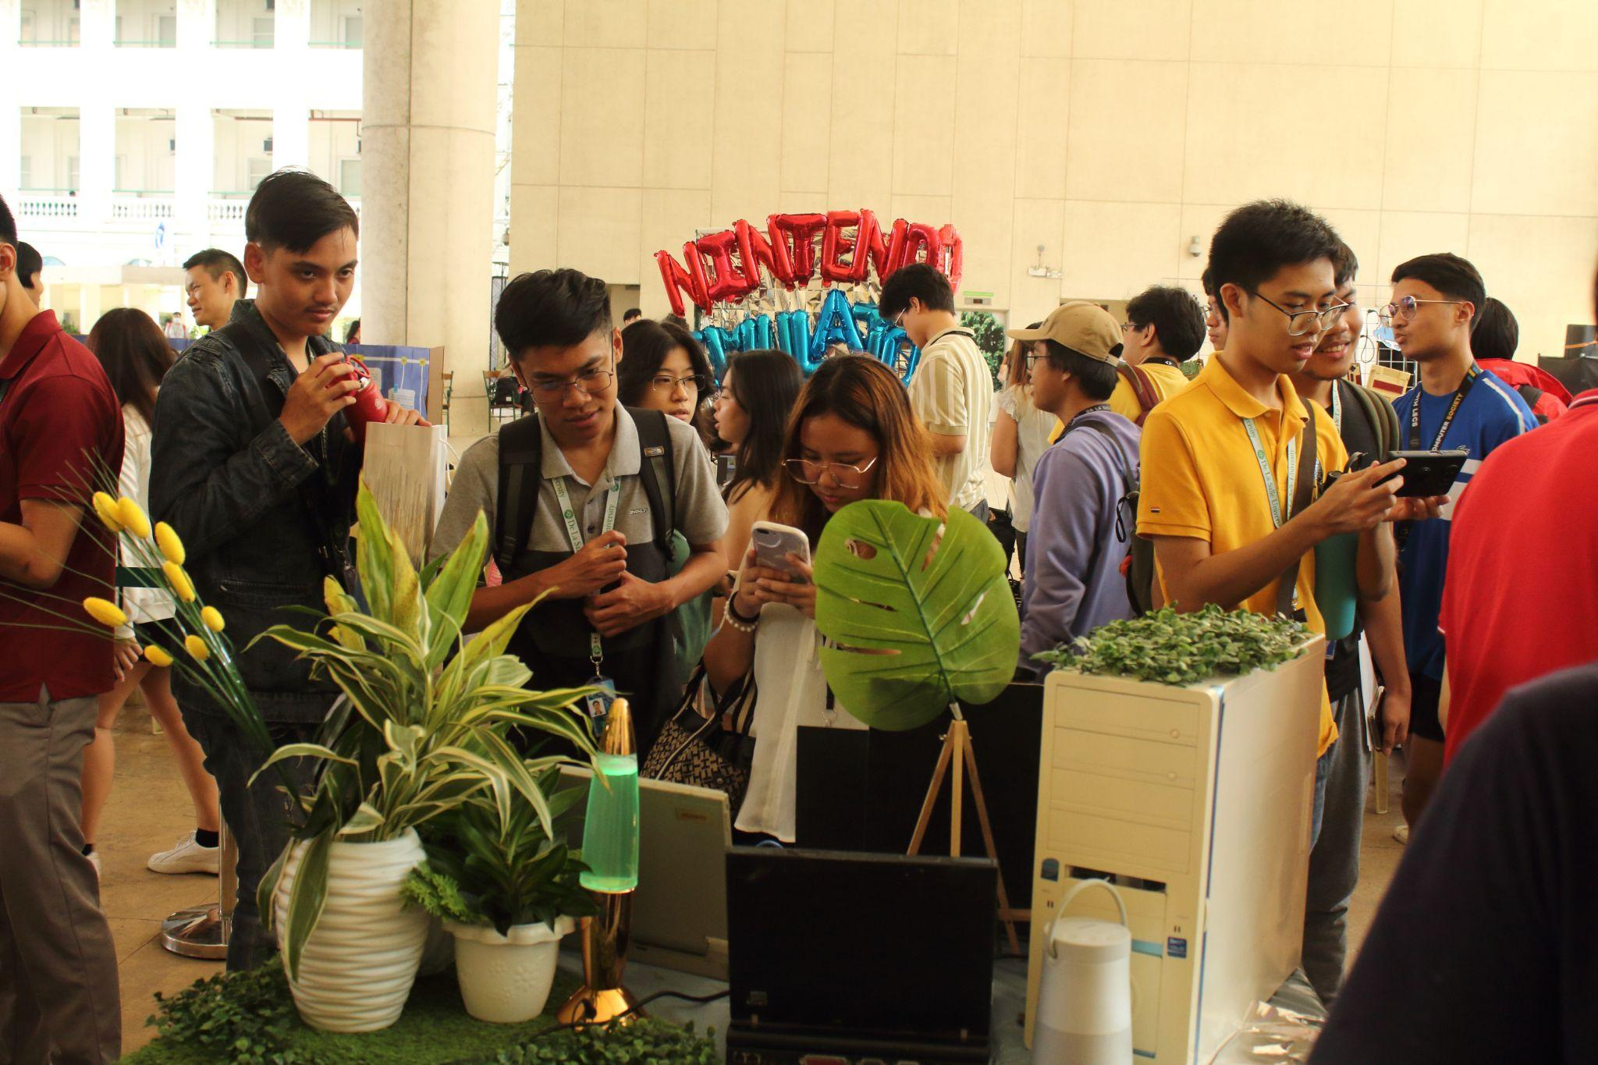

Students having a good time at the exhibit

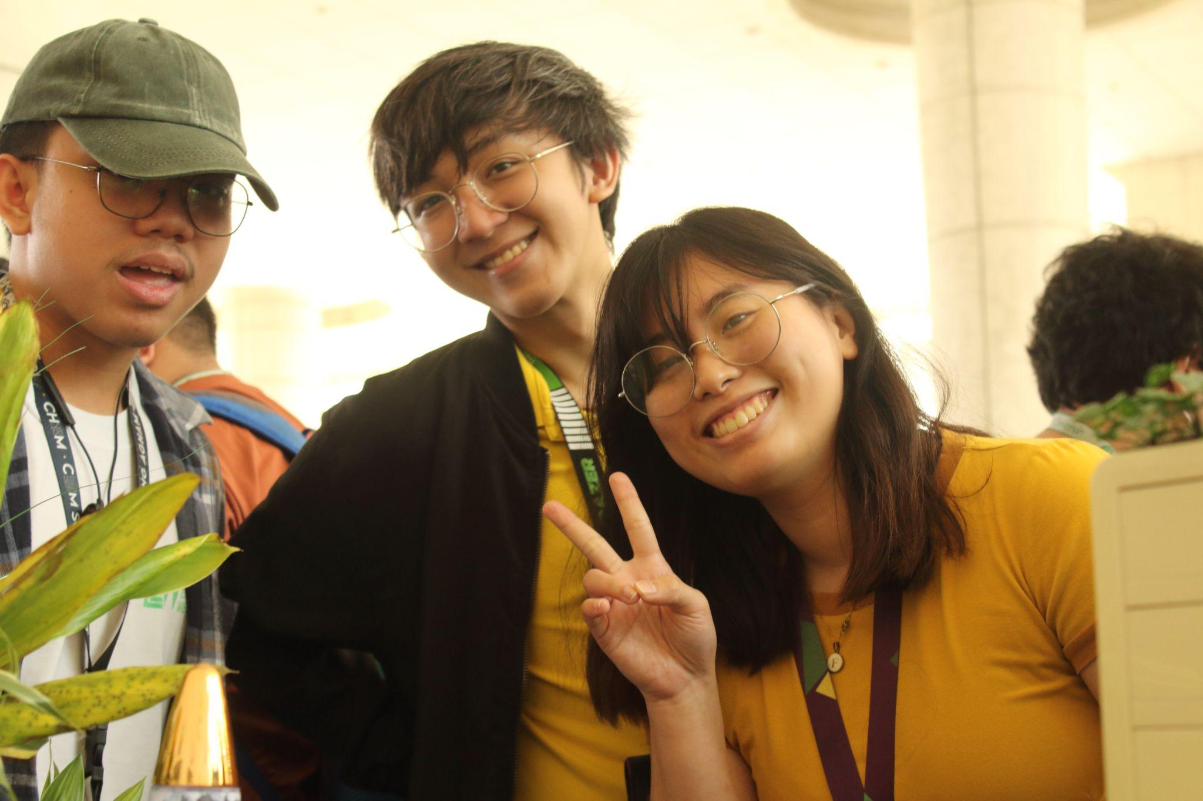

Visitors Log for the exhibit

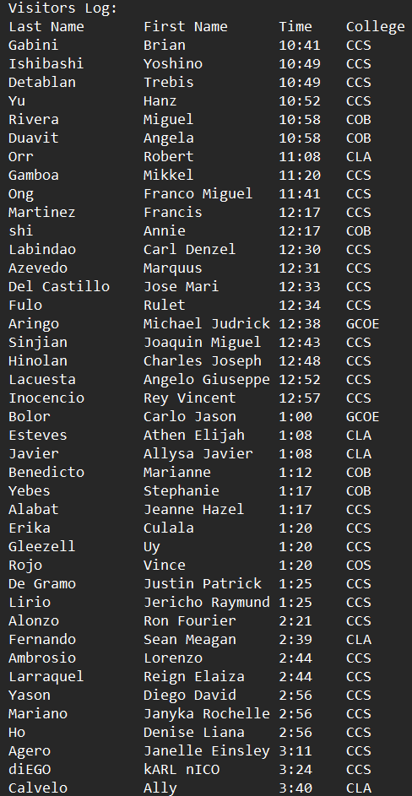

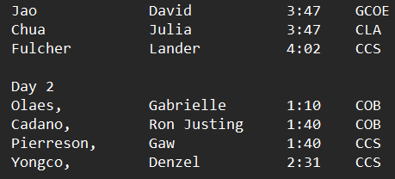

### Flyers used during the exhibit

Noah and Matthew Fernandez made the flyer and printed 30 copies of this flyer and handed it out to guests

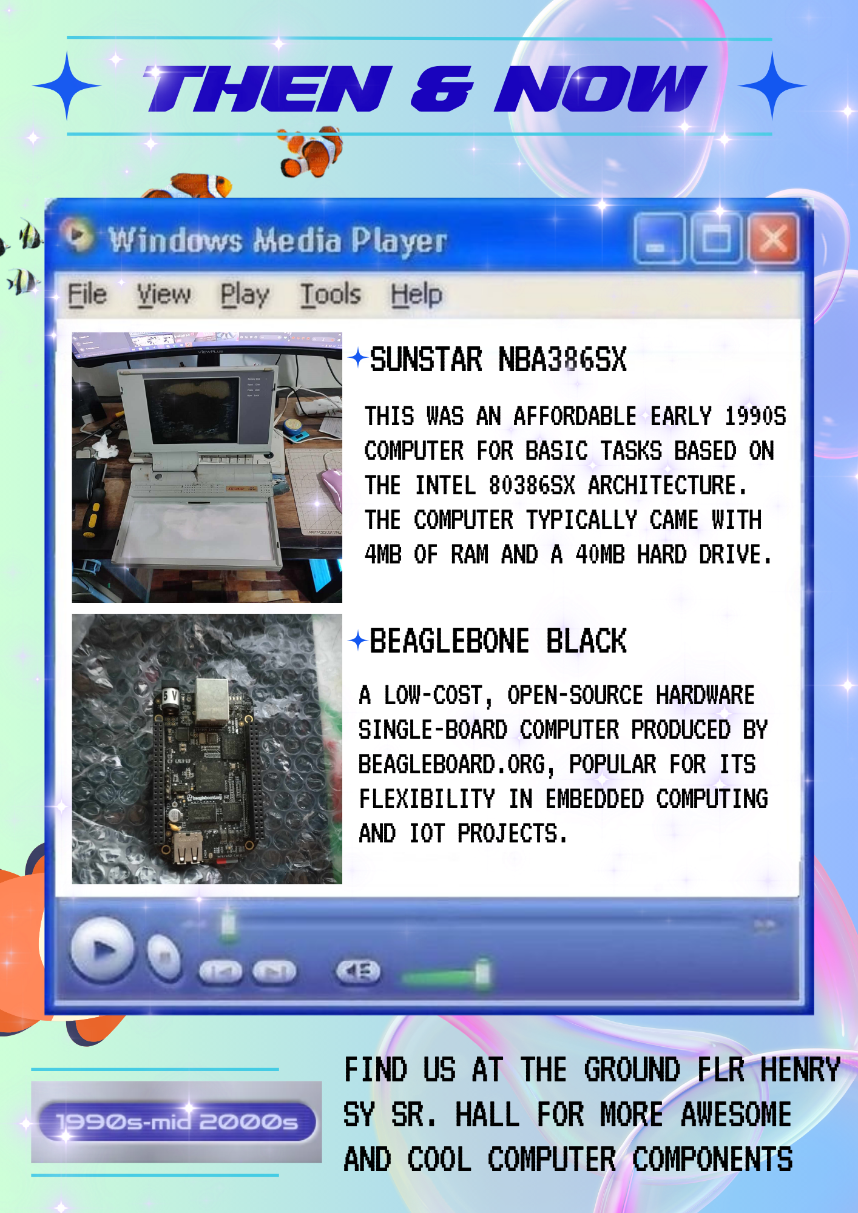

### Poster for the booth-setup

Richter made some poster for the booth-setup

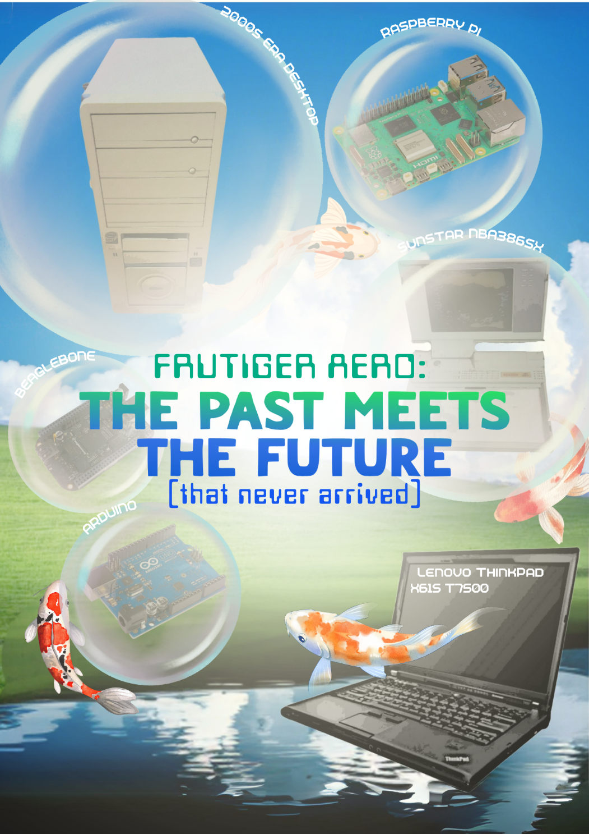

### Any other gimmicks used during the exhibit

Snippet of the Arduino code used for the Arduino demo

